Blogging Website

1. Welcome page

2. Login Signup page

3. News feed -> left (hamburger menu -> home, popular, explore, following communities ), middle (recent posts and blogs)

4. Community tab

5. Follow option

6. vote system

7. share

8. comment

9. profile section -> user name, full name, profile image, wall image, create post, past Posts or share post, community following, community followers.

10. nav bar -> logo, search bar, chat, create post, notification, profile icon (view profile, settings and logout, premium)

11.

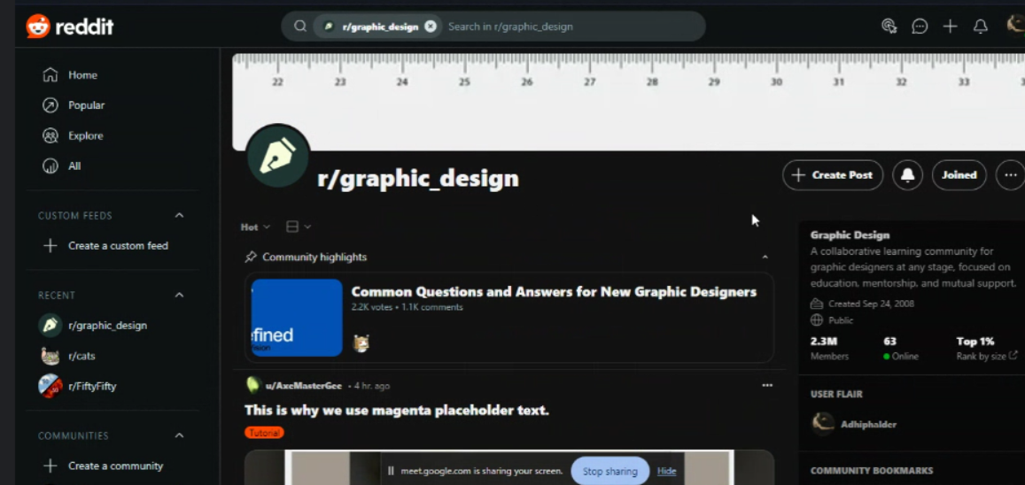

Here we don’t do the create post but the notification and the join status is required. And the home section and the mid section are done as same as possible.

**Log in Sign up feature for our system**

Sign up

Normal Name, Email and password

Optional Email Authenticator

Log in

email and password

**Admin**

Admin panel features ---→ For Adhip

Slidebar

0. all

1. Games

2. Techonologies

3. Movies

4. Travel

5. music

6. eduction

7. sport

8. News & Politics

9. Business FinanceL